**Practical Examination**   
Subject code: DBI202   
Duration : 85 minutes

**Requirements:**

+ Download the file **DB_PE_DBI202.sql** and execute it to create the database and the tables that are already in the file.

+ Submit your test with 2 files: sql code in **PE_DBI202.sql** and a word file as **ERD.docx** which contains your ERD at question 1.

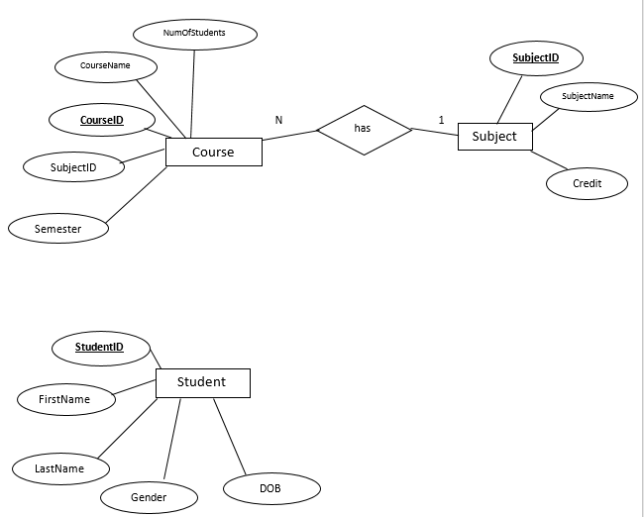

Enroll in

n

1

n

Enrolment

1

has

1. Complete the ERD by adding entity and relationships that meet the following requirements: Student can enroll many courses. **Attendance** - the number of absence slot and **gpa** scores of student must be stored on the database. (2 marks)
2. Write sql statement to create the table (- name the table: Enrolment-) from the entity that was adding into ERD at question 1. **Apply as much as possible constraints for each column of the table. (1.5 mark)**

**Write sql code to insert at least 3 records into the table (0.5 mark)**

1. Create a store procedure to enroll a student into a course. Do not allow duplicate enrollment: raise error if a student enrolls two times in the same course. (2 marks)
2. Create a function that calculate the total of credits of a student that enrolled in a semester. (2 marks)
3. Create a trigger to update **number of student** of a course (increase by 1) whenever a student enrolls into a course. (2 marks)